1.Add 10GB disk to the CentOS (I made in kali Linux).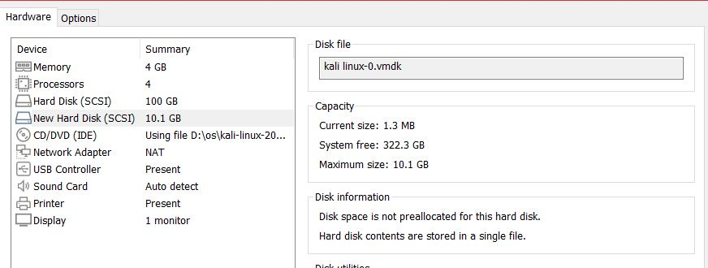

2.Create 2 partition 4GB and 6GB of space respectively.

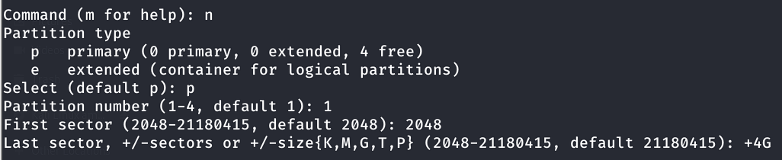

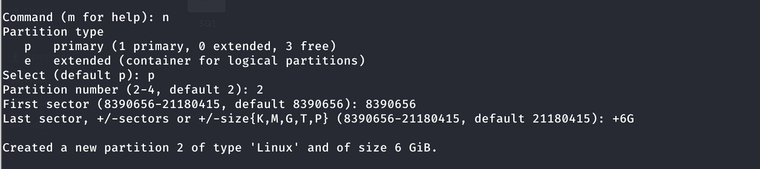

3.Format 4GB with XFS and 6GB of ext4 file system. 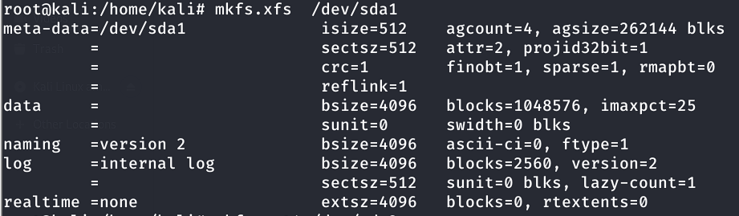

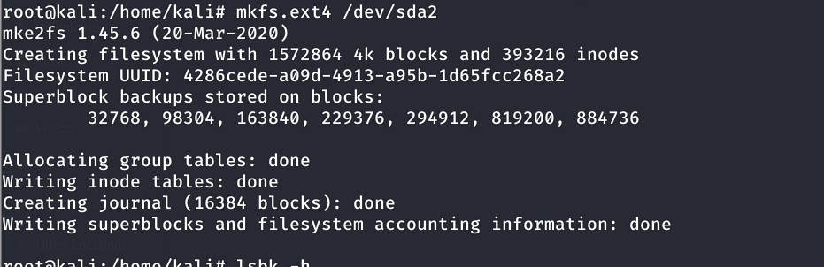

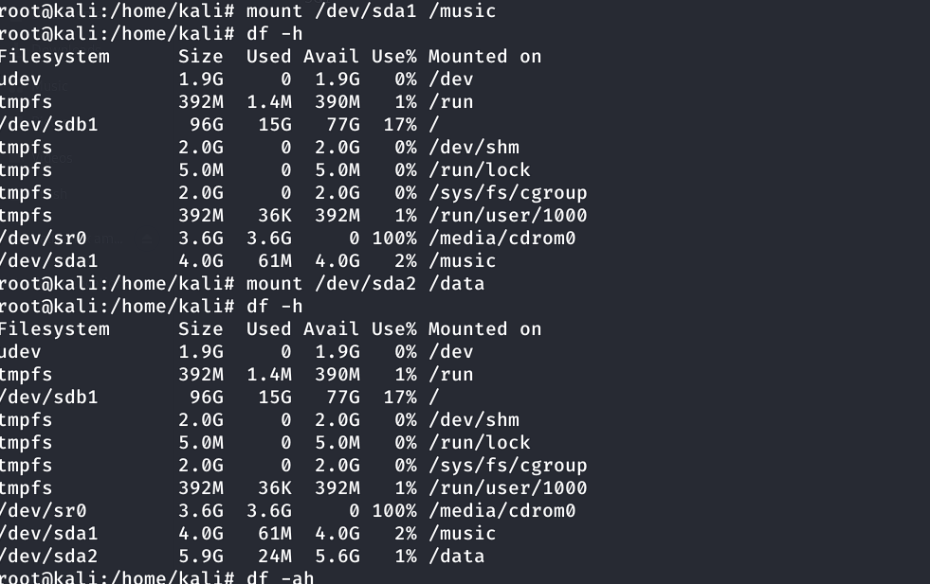4.Mount 4GB and 6GB in /data and /music directory respectively.

5.Create one file of 1 Gb in each of the mount point created above.



6.Verify the disk consumption and disk space free in the mounted partitions.

